Dunn Museum Re-Open Plan: Covid-19
Contents
1. Suggested Training and Supplies 1
2. Phase 4-Capacity Recommendations 1
3. Public Open Hours Schedule 1
4. Non-Public Hours Cleaning and Disinfecting Schedule 2
5. PPE, Cleaning and Disinfecting Procedures 2
6. Approved Disinfectant for Use Against SARS-CoV-2 from EPA 2
7. Cleaning/disinfecting checklist –Front end Museum 3
8. Cleaning/disinfecting checklist –Museum Gallery 4
9. Building Opening for Public Procedures 5
10. Front Desk Opening Procedures 5
11. Museum Gallery Opening Procedures 6
12. Front Desk/Lobby Closing Procedures 8
13. Register Closing Procedure 8
14. Museum Gallery Closing Procedure 8
15. Front desk staff and visitor interaction procedures 9
16. Merchandise handling 9
17. Enforcement of Protocols 10
18. Positive Covid-19 detection 11

March 17, 2021

- Suggested Training and Supplies
- Train all employees on appropriate cleaning and disinfection, hand hygiene, and respiratory etiquette. (Risk Management)
- Supply all employees with PPE (Risk Management) and social distancing resources:
- Cloth/disposable masks
- Disposable gloves
- Spray bottles of cleaning product/disinfecting product/disinfecting wipes, cloth rags
- Clear plexi-glass barriers at customer service points of contact
- Hand sanitizer-stations and bottles
- Safety Protocols signage (Public Affairs)
- Cleaning crew should be responsible for cleaning and disinfecting daily: bathrooms, lobby, hallways, staff café, and carpets.

- Phase 4-Capacity Recommendations

- Fire code capacity is 130 in the galleries.
- Operating at 25% in Phase 4 is about 32 people.
- Recommendation of 35 people in the galleries at a time. Potential max of 105 people per day.
- No volunteers in Phase 4.
- One staff person behind the front desk at a time.

https://dceocovid19resources.com/restore-illinois/restore-illinois-phase-4/museums/

- Public Open Hours Schedule
- One-day in-between public exposure to help take advantage of the virus’s natural life span of 24-48 hours.
• Disinfecting will happen on public days between visitor groups for all high touch surfaces. 30 mins.

Tuesdays open 10am-3:30pm
Thursdays open 10am-3:30pm
Saturdays open 10am-3:30pm

Admissions, 10am-11:30am: 25 ppl. Pre-paid online limit/ 10 walk-in available at front desk/ or sign up for next time slot.
Disinfecting, 11:30am-12pm: Disinfecting front desk, store, café- John or Alicia
Disinfecting exhibits- Steve, Robin or Heather
Admissions, 12pm-1:30pm: 25 ppl. Pre-paid online limit/ 10 walk-in available at front desk/ or sign up for next time slot.
Disinfecting, 1:30pm-2pm: Disinfecting front desk, store, café-John or Alicia
Disinfecting exhibits- Steve, Robin or Heather
Admissions, 2pm-3:30pm: 25 ppl. Pre-paid online limit/ 10 walk-in available at front desk/ or sign up for next time slot.

- Non-Public Hours Cleaning and Disinfecting Schedule

- Cleaning and disinfecting on non-public days will allow for thorough cleaning and sanitizing the museum and make sure it is ready for next morning.

Monday Mornings: Front Desk, Store, Café - Alicia- cleaning and disinfecting
Exhibit Galleries- Steve- cleaning, Robin-disinfecting
Wednesday Mornings: Front Desk, Store, Café - Alicia- cleaning and disinfecting
Exhibit Galleries- Steve- cleaning, Robin-disinfecting
Friday Mornings: Front Desk, Store, Café - Alicia- cleaning and disinfecting
Exhibit Galleries- Steve- cleaning, Robin-disinfecting
- PPE, Cleaning and Disinfecting Procedures
• PA announcement will be made about having to close to disinfect, 15 mins. before close time and at close time.
- Once everyone is out of the museum, close all entry points.
- Wear disposable gloves, eye protection and mask to clean and disinfect.
- Clean with approved cleaning solution or soap & water, rag to rinse clean Cleaning/disinfecting checklist page 4 and 5.
- Disinfect with Clorox wipes or Sani-Spritz spray and rag. Cleaning/disinfecting checklist page 4 and 5.

- Approved Disinfectant for Use Against SARS-CoV-2 from EPA
- Clorox wipes- 4 mins. contact time
https://www.epa.gov/pesticide-registration/list-n-disinfectants-use-against-sars-cov-2
- Nyco® Sani-Spritz (#NL763-Q12)- 10 mins. Contact time
one step disinfectant, cleaner, fungicide & virucide.
EPA Registration # 6836-152-8370, approved by the EPA criteria for use against SARS-CoV-2, the virus that causes COVID-19.
- Cleaning/disinfecting checklist –Front end Museum
Rag and approved cleaning spray:
- Door handles/push bars
- Lobby table tops/ chairs
- Front desk counter tops/swing door
- Credit card machine
- Pens / pencils used
- Phones
- Keyboard/mouse
- Touchscreen monitors
- Product scanner
- Cash till
- Front desk chair arms/backs
- Laminated info sheets
- Drawer handles
- Drypto button
- Suggestion box
- Blinds handle
- Survey clipboards
- PA buttons/keyboard computer
- Lobby screen keyboard/mouse
- Garbage lids
- Donation box
- Café chairs-metal parts
- Café table tops
- Café napkin containers
- Highchairs
- Vending machine buttons
- Cart
- Wheelchairs
Clorox Wipes/ Sani-Spritz - after cleaning-disinfect same +:
- All remotes at front desk
- All keys at front desk

- Cleaning/disinfecting checklist –Museum Gallery

- Most exhibit touch elements should be closed off or taken out.
- Soft surfaces (animal hides, cloths for picnic basket) should be removed.
Prehistoric:
Rag and approved cleaning spray:
- Drypto signs on the base
- 3 skulls
- Tooth replicas
- Push Buttons for TV
- Touch screen monitor
- Dig pit edge
- Angled labels
- Plexi with fingerprints
- Benches

Lysol spray:
- Drypto
- Fossil Rock

First People:
Rag and approved cleaning spray:
- Wigwam benches
- Touch screen monitor
- Flipbook
- Angled labels
- Plexi with fingerprints
- Glass case – wipe with dry cloth after wiping with wet rag

Settlement:
Rag and approved cleaning spray:
- Bonner chest rail glass
- Schoolhouse benches, angled desks, podium, stove handle
- Bench outside schoolhouse
- Angled labels
- Plexi with fingerprints
- Glass case – wipe with dry cloth after wiping with wet rag

Civil War:
Rag and approved cleaning spray:
- Touch screen monitor
- Gatling Gun rail and push button
- Quilt case
- Angled labels
- Plexi with fingerprints
- Glass case – wipe with dry cloth after wiping with wet rag

Innovation 1:
Rag and approved cleaning spray:
- Bench
- Touch screen monitor
- Train table
- Angled labels
- Plexi with fingerprints
- Glass case – wipe with dry cloth after wiping with wet rag

Innovation 2:
Rag and approved cleaning spray:
- Bench
- Touchscreen monitor
- Magniscope case
- Angled labels
- Plexi with fingerprints
- Glass case – wipe with dry cloth after wiping with wet rag
- Exit push bar on door

Lysol spray:
- Lotus Boat

Woodland Theater:
Rag and approved cleaning spray:
- Benches
- Angled labels
- Plexi with fingerprints

Special Exhibition Gallery:
Rag and approved cleaning spray:
- Bench
- Angled labels
- Plexi with fingerprints
- Push Buttons for TV

- Building Opening for Public Procedures
- Begin opening procedures at least 30 minutes prior to museum opening time.
- Enter through staff entrance with key card access.
- As you enter, disarm alarm panel located past the second set of doors on the left.
- After disarming alarm, sign in on pad of paper above alarm panel.
- Always check that the exterior staff door is locked behind you.
- Enter Museum by key card or keys.
- Wash or sanitize hands before entering Museum
- Put on disposable gloves and mask provided for staff.
- Change gloves after each cleaning and/or disinfecting and wash or sanitize your own hands.
- Disinfect all remotes and keys required for opening.
- Take main museum keys from the front desk.
- Turn on lights in lobby of building, located on the right side of the elevators.
- Open the light cover and activate by turnkey.
- Turn on Lobby projectors with projector remote. (labeled)
- Turn on the projector computer and keyboard on top of the front desk cabinet.
- Double click the World Viewer icon on the desktop
- Two screens should appear with a Dunn Museum slide.
- Click on the left screen and press the Escape button on the keyboard.
- A list of options should appear. Double click on Load Composition.
- Select the Tuesday- Sunday file and double click. (on Mondays select Monday and on Sundays select Sunday)
- Turn off computer screen and keyboard.

- Front Desk Opening Procedures
- Disinfect all front desk computer keyboards, touch screens, phones, counter top, door handles, and chair arm rests
- The rest of the store, café and exhibits have been cleaned and disinfected the previous day.
- Change gloves after each cleaning and/or disinfecting and wash or sanitize your own hands.
- Turn on both front desk computers
- Sign into computers BBD-POS1 and BBD-POS2
- Double click on POS PROPHET Systems 3.0 in the bottom left corner of the screen
- Sign into POS program
- Get money from safe. (with gloves on)
- Count money into register 2.
- We will operate with only one register able to take cash as a last resort.
- Change gloves after handling money.
- Register should equal $100. If it does not, report to VS Manager and leave a note on the register.
- Check the desk for any temporary procedures printed out.
- Unlock building front door at 10am, by unbolting the deadbolt located in the middle of the doors and then flipping on the power switch located on top of door entrance.
- Prop open the museum front doors at 10am.

- Museum Gallery Opening Procedures
- The galleries have been cleaned and disinfected the previous day.
- Change gloves
- Light switch key is located on the museum main keys. You will need the key to activate all 9 light switch panels within the galleries.
- Insert key on a downward angle and lift up to turn on.
- Insert key on an upright angle and lower down to turn off.
- Lights in classroom and reading room spaces are motion sensor activated. No need to turn on or off.

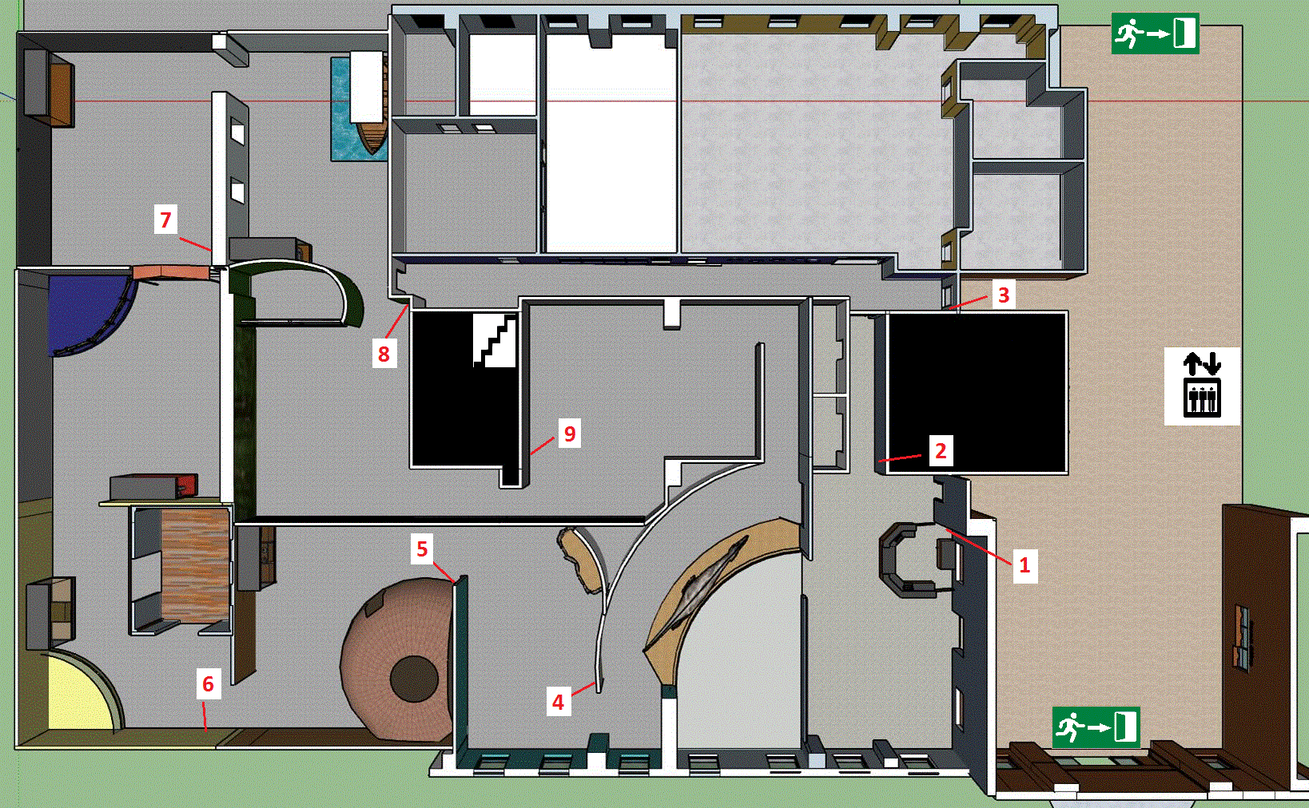
Light locations pictured below. Start in order from 1-9 to turn on all lights

- Turn on all interactive elements in galleries. Remotes and additional keys located at the Front Desk.
- Turn on all T.V. screens with the remote labeled TV.
- Check Tree interactive computers. They should all be on. Reset the maps by pressing any of the interactive tabs on the screen. A small hole with an on/off button located inside at the bottom right of the screen.
- To restart the interactive computer simply get a poking device (paperclip) and push in to turn off the computer and then push in again to turn on.
- Wigwam fire starts and stops automatically.
- Wigwam star screen requires a key to turn on. Key is located on the museum keys.
- Insert star screen key into light panel located inside the wigwam on the wall to the left.
- Insert key in the right switch and pull down to turn on stars.
- Insert key in the left switch and push up to turn on the lights in the case.
- Use white remote on museum keys to turn on additional lights in the wigwam. Press first button down the row under ON.
- Woodland Theater needs two remotes. One white remote for the projector and one black remote for the media player.
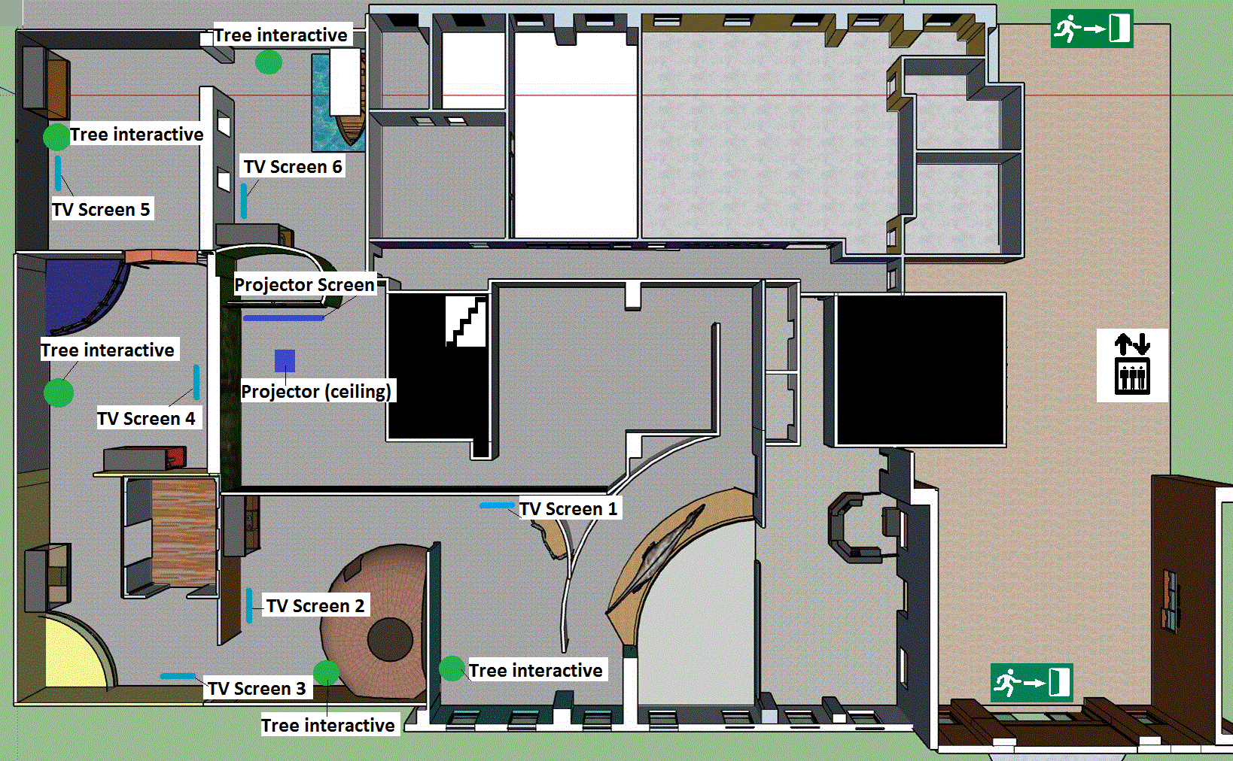
- Turning on and off the media player in the Woodland Theater Gallery may make a loud popping sound. The media player is located above the screen on the right side.

- Front Desk/Lobby Closing Procedures
- 3:00-3:30pm- Make sure visitors are aware that the museum will close at 3:30pm.
- 3:15 pm- the PA system is programed to let visitors know that the museum will close in 15 mins. If the system does not work walk the galleries to tell visitors, while keeping 6 ft of distance, that we are closing in 15 mins. Be polite.
- 3:29 pm- the PA system will have one more announcement to let visitors know the museum is closed.
- 3:30 pm – close and lock the museum front door if no visitors are in the museum at closing time. If visitors are still in the galleries after closing time feel free to politely remind them that the museum is closed and to please make their way to the lobby.
- If visitors are in the store shopping after closing time please be patient and let them finish shopping before you close the register. Monitor security cameras to make sure there are no visitors left in the galleries.
- Do not close register before 3:30 pm if visitors are in the museum.
- Once all visitors are gone from the museum, close museum doors and make sure they are locked.
- Change gloves
- Using the lobby projector remote turn off the projectors in the lobby. Press the power button twice for each projector.

- Register Closing Procedure
- Change gloves
- Make two different envelopes for the day. One for Credit card receipts. One for cash.
- Use different gloves and different envelope for cash deposit.
- Write Cash on outside of cash envelope
- Cash transactions should only go through register 2
- Change gloves after cash deposit and continue with separate deposit envelope
- For detailed POS instructions refer to main VS Manual
- Add up all credit card receipts and/or checks. Make sure those add up to the amount on the Totals Receipt.
- Count out the cash deposit and place in separate envelope.
- Recount the $100.00 in the drawer making sure it is $100.
- Place $100 back into money pouch and back in the safe.
- You should have in the envelope:
  - Cash deposit
  - Checks deposit
  - All credit card receipts
  - Totals receipt
- If there are any discrepancies, fill out the cash overage/under form at the front desk and include in deposit envelope.
- Take the daily deposit envelopes to the safe.

- Museum Gallery Closing Procedure
Public Emergency Exit
- Change gloves
- Make sure all museum doors are locked and check that the push bar is securely over the latch.
- Grab all keys and remotes from the front desk.
- Walk through galleries and turn off lights and interactives starting in the Temporary Exhibit Gallery. Opposite from where you start for opening.
- Turn off projector and media player in Woodland Theater gallery.
- Turn off all lights and T.V. screens.
- Turn off the lights and star interactive inside the Wigwam. Wigwam fire turns off automatically.
- Make your way back to store area.
- Place remotes and any keys back at the front desk.
- Exit Museum knowing all doors are secure.
- Throw away gloves
- Wash hands

- Front desk staff and visitor interaction procedures
- maintain at least 6 feet separation from other individuals
- All signage and website will say No Cash transactions
- Visitor admission payments will be processed online. Time ticketed per 1.5 hours for visitors.
- If there is space available based on the amount of visitors already in the museum per hour, then in-person, admissions will be accepted by credit card payment. In the case that a visitor only has cash payment available, then you may take admission for them at register 2.
- Do not use the same gloves to work at register 2 for cash transactions. Change gloves and dispose of after.
- Enter walk-in visitors through POS register
- Enter online sales through POS register under Online Admission button for attendance.
- Visitor Services staff will need to login to the Administrative website in order to have the most current list of online admission tickets.

- Merchandise handling
- Must have clean gloves on when handling merchandise at any time
  - Visitor purchases
  - Receiving merchandise
  - Pricing merchandise
  - Putting merchandise on the store floor
  - Cleaning merchandise displays

- Signs on merchandise tables letting visitors know that gloves are provided at the front desk for touching merchandise.
- Signs on merchandise tables outlining the measures staff is taking in order to keep merchandise clean.
- Signs on merchandise tables saying Please bourse with your eyes. If you would like to touch any merchandise please ask for gloves at the front desk.
- If practical, monitor what merchandise visitors touch to disinfect after they leave
- If practical, move merchandise out of children’s reach

- Enforcement of Protocols
It will be all staff’s responsibility for enforcing wearing masks and social distancing with the public. Below are acceptable statements to inform visitors about protocols.

- We require masks, good hand hygiene, and respiratory etiquette while at the Dunn Museum. Disposable masks and hand sanitizer are available to you throughout the galleries. (Children under 2 do not require a mask).
- Please practice safe social distancing of 6 ft apart from other visitor groups and follow all distancing signs.
- Please follow all signs dedicated to one-way routes.
- Please do not enter the Dunn Museum if you are experiencing symptoms consistent with Covid-19.
- We advise everyone who visits to follow Center for Disease Control & Prevention recommended Covid-19 prevention strategies.
- We appreciate your help in keeping you and other guests healthy.

In the rare event that an individual may refuse to follow any of the protocols, here are acceptable statements and measures to take.
- We as staff are here to make sure everyone is safe by carrying out the safety protocols that have been given to us. If you are not willing to help do your part in those safety protocols, (mask, social distance) you will be asked to leave.
If the conversation escalates from the visitor into verbal abuse such as, foul language, name calling, threatening language against you or anyone else’s physical safety or property damage.
- I will need to call our Ranger Police if you do not stop talking to me this way and they will ask you to leave.
If they comply, do not call.
If not, call.
If physical harm to persons, damage to property, or deliberately disregards what you have said and goes into a facility knowing fully well the protocols.
- I am calling the Ranger Police. Call.
*Panic button if necessary.
*If in immediate danger always call Ranger or 911 first but make sure to call manager on duty as well.

- Positive Covid-19 detection
Below are a list of guidelines for instances where employees or if notified that a visitor to the museum tested positive for COVID-19.

Visitors
- In the event of the district being notified through contact tracing that a visitor to the museum tested positive for COVID-19 within 2 weeks of visitation date:
- The Museum will immediately close. Public Affairs staff are responsible for updating social media, etc… The Visitor Services Manager is responsible for contacting any patrons that have purchased timed tickets for the period that the museum is closed.
- A contracted vendor will deep clean the museum.
- It is recommended that any staff that have been in contact with positive visitors should get tested on their own. Any staff that have been in contact will be asked to self-quarantine for a minimum of 7 days
- If staff that have been in contact with positive visitor test negative for COVID-19 or complete the required self-quarantine period, Museum will re-open as soon as deep cleaning is done.
- If staff that have been in contact with positive visitor are positive, Museum will need to stay closed until staff have been symptom free for 3 days and are able to return.
Staff
- In the event an employee tests positive for Covid-19, the work facility (GO) for this employee will be closed until an outside company can provide deep cleaning.
- Staff will be prohibited from entering those locations until cleaning is complete.
- Staff will either stay home or function in a different way based on what department/function was impacted.
- Those who may have worked directly with the employee will be notified.
- Employees will be instructed to isolate for at least 7 days from the onset of symptoms or their positive test (whichever was first). They must be fever/symptom free without medication for at least three days before returning to work. They will also be instructed to provide a medical release before returning to work.
- All touchpoints that these employees have come into contact with will be thoroughly cleaned and disinfected.

Continue to practice the following:
- Continue to follow the protocols that have been established for your worksite including face covering, hand washing, ensuring social distancing and eliminating of touch points.
- Avoid touching your face, mouth, nose and eyes with unwashed hands.
- Frequently clean hands with soap and water for at least 20 seconds, after glove use and before eating, drinking or smoking.
- If soap and water are not available, use any alcohol-based hand sanitizer.
- When coughing and sneezing, cover your mouth and nose with a flexed elbow or tissue and immediately wash your hands.
- Avoid close contact with anyone who has a fever and/or cough.
- If you have a fever, cough, sore throat, difficulty breathing and/or any other symptom of COVID-19 or if you have had close contact with anyone who has tested positive for COVID-19, notify your manager and seek medical care.

